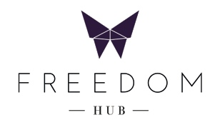

Bacon & Egg Roll
crispy bacon, egg, house made relish, aioli, bun
$10

Organic Sourdough Toast w/ Eggs
(poached, fried, scrambled),
house made chutney
$11
+ Extras
bacon, prosciutto, smashed avo, mixed mushrooms
$4 each

——

Chia Coconut Granola Bowl (V)
chia pudding, coconut yogurt, granola, seasonal fruit
$12

Smoothie Bowl (V)
choice of berry or green topped with fresh fruit, nuts
$12

——
Avo Smash
smashed avo, fried chickpeas, lime, chilli flakes, sourdough
$12
+ poached egg $3
+ bacon $4

Confit Salmon
slow cooked salmon, kale, labne, poached egg, chilli garlic sourdough $15

Brekkie Board
prosciutto, smashed avo, mixed mushrooms, eggs, hommus, house chutney, sourdough
$18

——

Summer Bowl (V)
roasted cauliflower, fried chickpeas, brussels, fried onion, baby spinach, tahini
$12
+ chicken $3

Brown Rice Bowl
thai beef, roasted rice dressing, soft herb salad, brown rice
$16

——

Seasonal Toasties
ham, cheese, dijon
$8
mixed miso mushrooms, gruyere, chives
$10
chicken, spicy mayo, provolone, walnut, kale
$14

——

Cakes and Slices
see fridge

100% of profits support survivors of modern slavery.

